### SUN SAFETY

Sunny days have a positve impact on mood, increases our physical activity, makes social events possible, and benefit health by providing our bodies with vit D.

Unfortunately sun exposure also presents risk factors that can lead to eye and skin damage, and skin cancer. Prevention and early detection are the best ways to keep skin healthy. Remember:

**Wear sunscreen** with a sun protection factor (spf) of 30 or higher,30 minutes before exposure,reapply every 2 hours.

“**Broad spectrum** “ sunscreen to protect against UVA &UVB rays. **Avoid peak UV** **radiation** between 10am and 3pm.

**Wear wide brim hats**, sunglasses with 100% UV protection, wear light weight

loose fitting clothes that cover large areas of skin-dark or bright colors are best.

**Perform skin self-exams** regularly to become familiar with existing growths and to notice any changes or new ones.

**Avoid** tanning beds.

Sun damage may not be apparent while young, but will definitely show later in life.

Source: cancercare.org

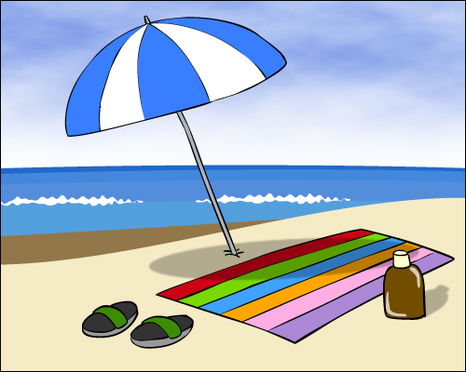

**EDEN PARK SCHOOL JUNE 2013 Newsletter**

**SUMMER SAFETY**

## Date

### Happy Father’s Day to our Eden Park dads!! Thank you for all you do.To stay healthy:

Get recommended screenings.

Be tobacco free.

Be physically active.

Eat a healthy diet.

Stay at a healthy weight.

Source:www.umm.edu/news/releases/fathers

### Emergencies

Public health emergencies such as

floods, hurricanes, and health pandemics are unpredictable. Take steps to protect health and safety in

every situation: **Make a kit** with first aid supplies, batteries, flashlight, food,

water,medicines. **Make a plan** to know how to reach family members,

designate meeting place.

**Stay informed -**follow advice oflocal

& state officials. Emergency numbers:

RI emergency management:946-9996

RI dept health/emergency: 222-5960

[www.health.ri.gov/emergency/](http://www.health.ri.gov/emergency/)

[www.ri.gov](http://www.ri.gov) click on Agencies, enter in

Search:Personal Emergency

Preparedness Guide

Prevent

|  |  |  |  |  |
| --- | --- | --- | --- | --- |
| **monday** | tuesday | wednesday | thursday | friday |
|  |  |  |  |  |
| 3 | 4 | 5 | 6 | 7 |
| 10 | 11 | 12 | 13 | 14 |
| 17 | 18 | 19 gr 6 | 20 | 21 happy  summer |
| 24 | 25 | 26 | 27 | 28 |
|  |  |  |  |  |